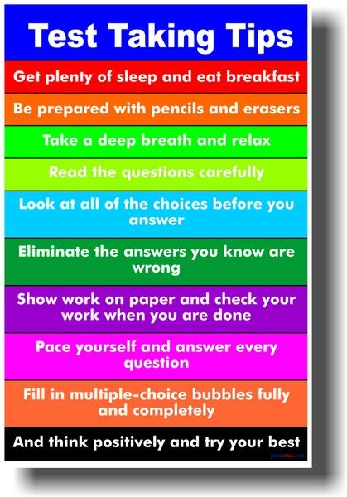
2016
Ray Thompson
April
Calendar

6th ~ J.P. Dice, Fox 6 News
7th ~ Picture Day
~ Cap & Gown Pictures, Pre-K, Kindergarten and 5th grade
~ 5th grade Career Day @ GSCC
12^{th ~} 5th grade strings concert @ GCHS, 7:00 p.m.
18th-22nd ~ ACT Aspire Testing Week
25th ~ Progress Reports go home
27th ~ Early Release, 12:30 p.m.
28th ~ City wide Track Meet
29th ~ Tech Blitz

